STUDENT INFORMATION:

Name
Address
City State_____________ Zip
Date of Birth _________________________ Age
Grade in school
Current Dance Level # of years studied
Current Dance School

T-Shirt Size:  Youth Small,  Youth Medium,  Youth Large
 Adult Small,  Adult Medium

IN CASE OF EMERGENCY CONTACT:
Name
Phone #
Alternate Phone #
Contact email:

MEDICAL & RISK WAIVER
I hereby give my permission for my child to participate in the activities of the Youth Summer Ballet Intensive. I release Central Indiana Academy of Dance, its Owners and Employees from any responsibility for any accident or injury that could occur. I have alerted the staff of any problems or medical restrictions that my child has. I am aware that any dietary concerns should be covered by myself and controlled by providing a proper sack lunch and snacks.

ANY CONCERNS?

GUARDIAN’S SIGNATURE
DATE

CONSENT
I understand and allow: light touching of appropriate body parts necessary for purposes of instruction; any photo and video materials with my child’s participation to be free for further use by Central Indiana Academy of Dance.

GUARDIAN’S SIGNATURE
DATE

Registration and Fees ($300/student) are due by May 8, 2021

LIMITED SPACE AVAILABLE
PAYMENT DUE AT REGISTRATION & ALL FEES ARE NON-REFUNDABLE

Mail or drop off at:
CENTRAL INDIANA ACADEMY OF DANCE
14950 GREYHOUND COURT #4 CARMEL, IN 46032
317-581-2423 * studio@ciaodance.com

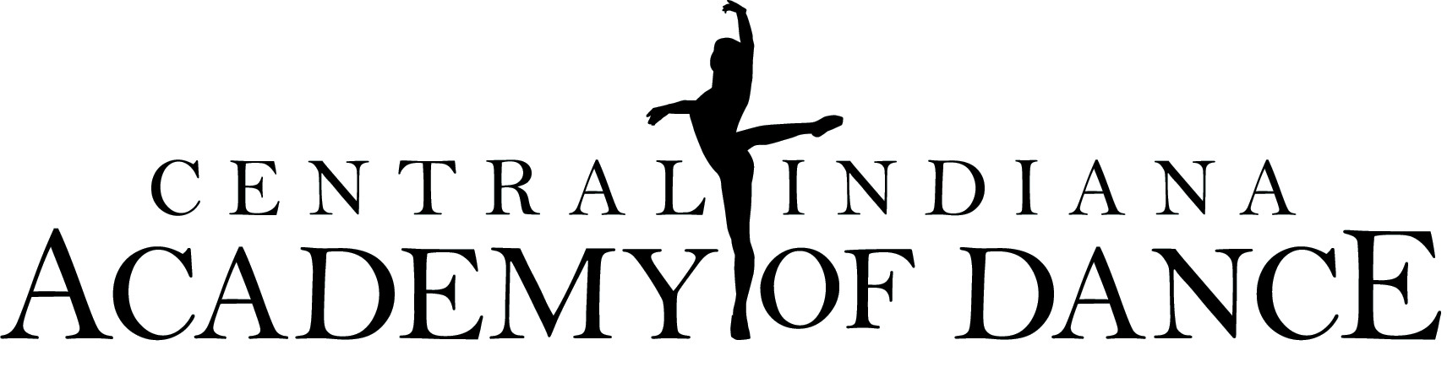

YOUTH SUMMER BALLET INTENSIVE
JULY 12-16, 2021
FOR STUDENTS AGES 7 TO 9

BEGINNING (MINIMUM 1 YEAR BALLET TRAINING)
ELEMENTARY (MINIMUM 2 YEARS BALLET TRAINING)

CLASSES HELD FROM 9:30 AM TO 3:00 PM DAILY
PARENT SHOWCASE, FRIDAY JULY 16, 2021 (TIME TBA)

FEE $300 (ALL TUITION IS NON-REFUNDABLE)

DRESS CODE (WILL BE ENFORCED)
GIRLS: Black leotard, pink tights, pink ballet shoes, jazz shoes. Hair in bun. No jazz sneakers or jewelry
BOYS: Black unitard/tights, white t-shirt, black/white ballet shoes, jazz shoes. No jazz sneakers or jewelry.

**Dancers will need to bring a sack lunch and water bottle each day.

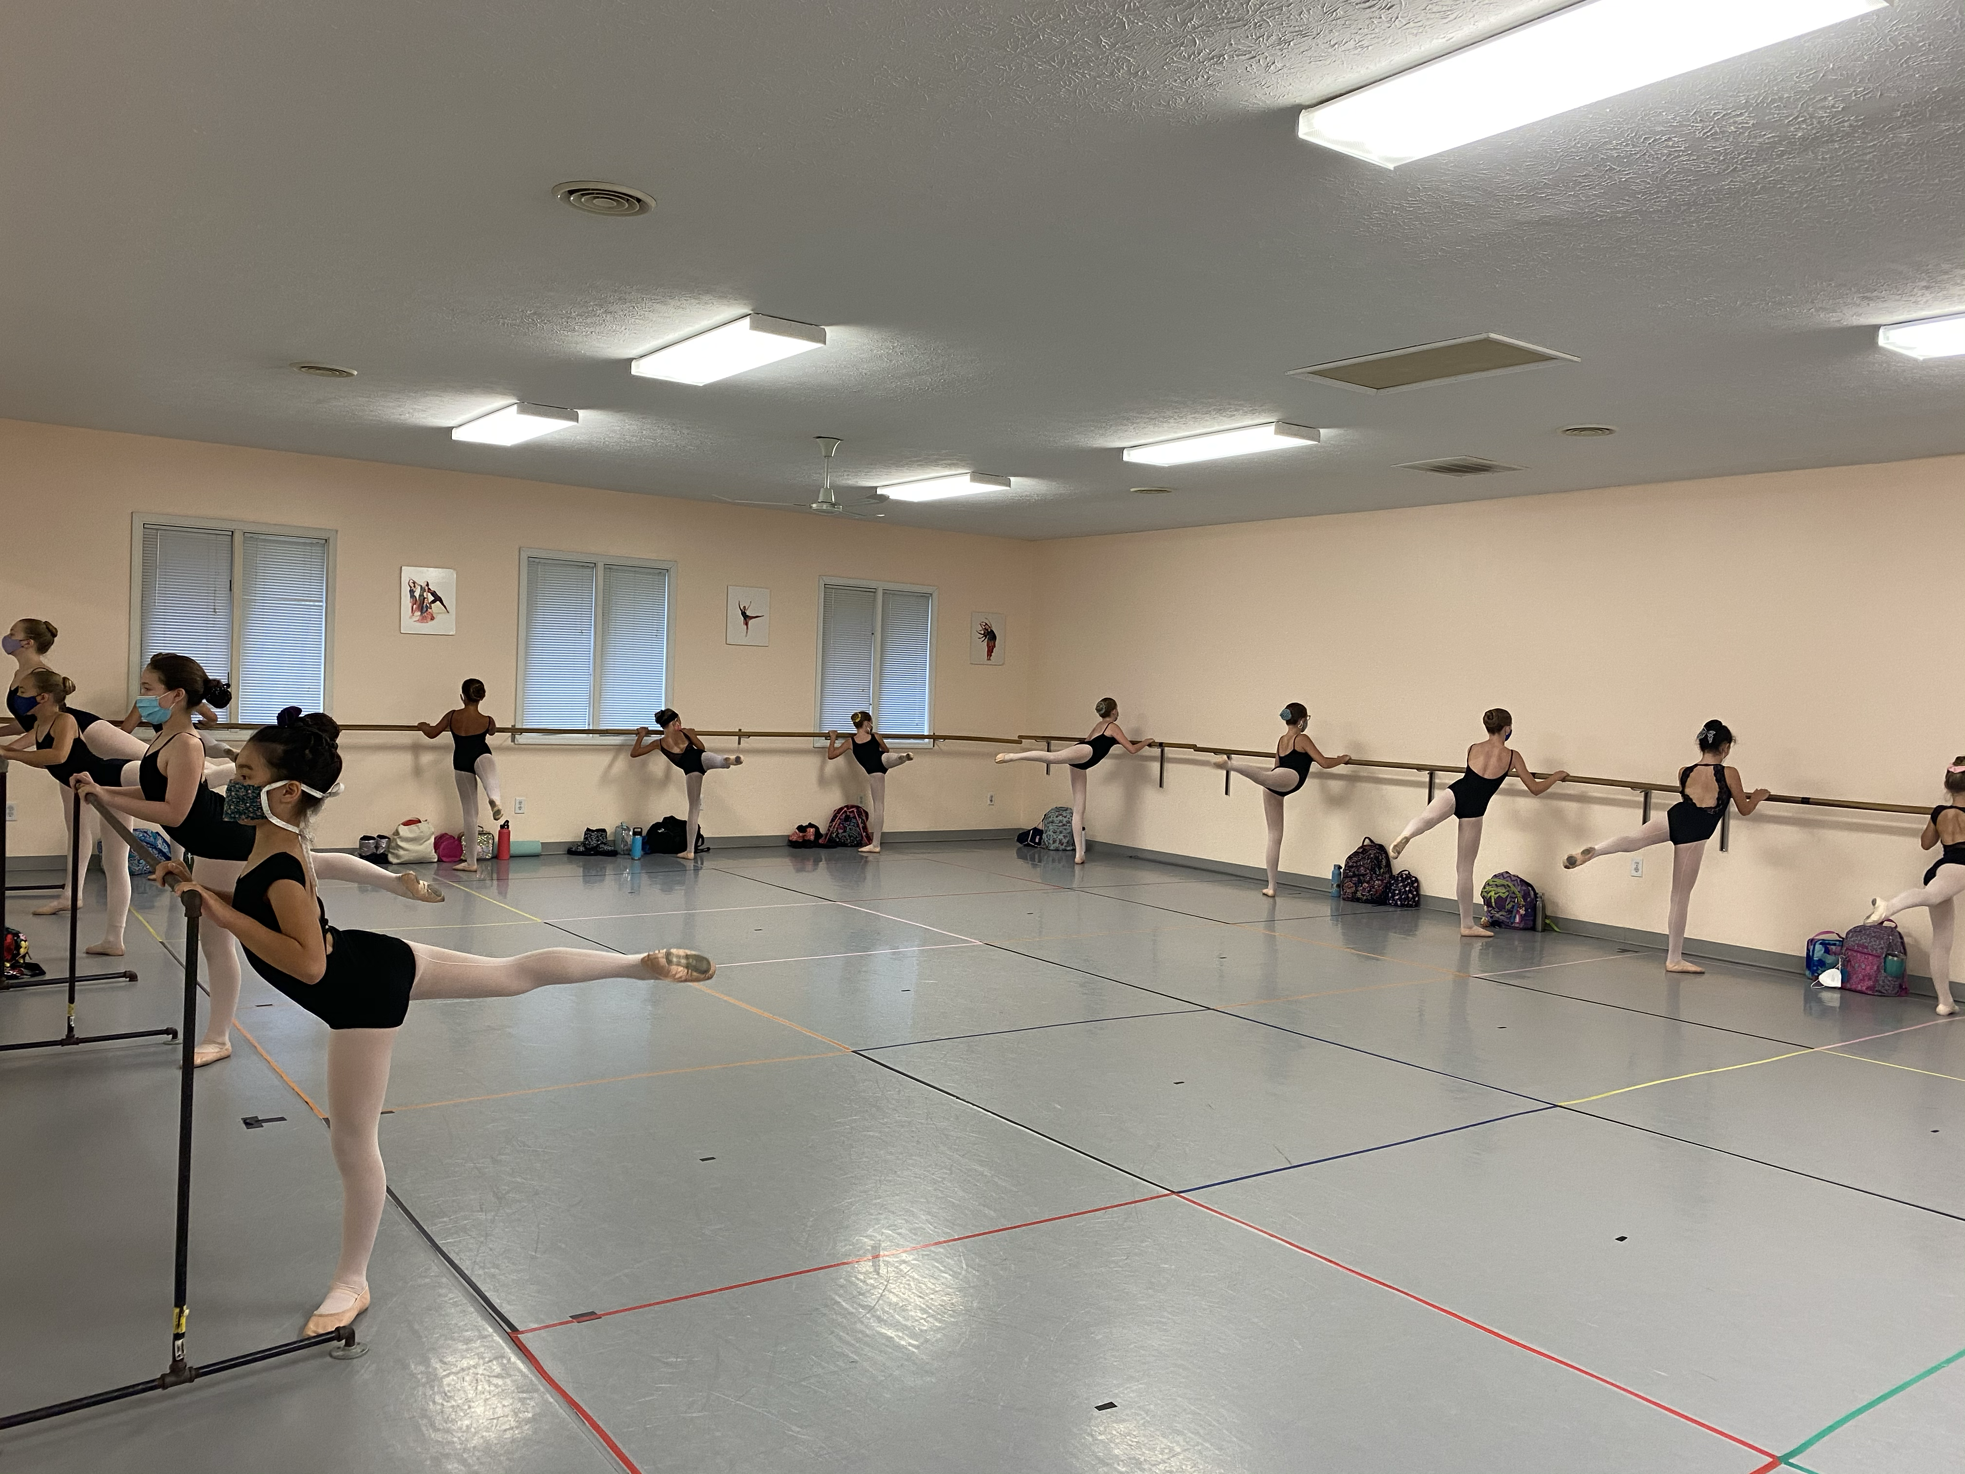
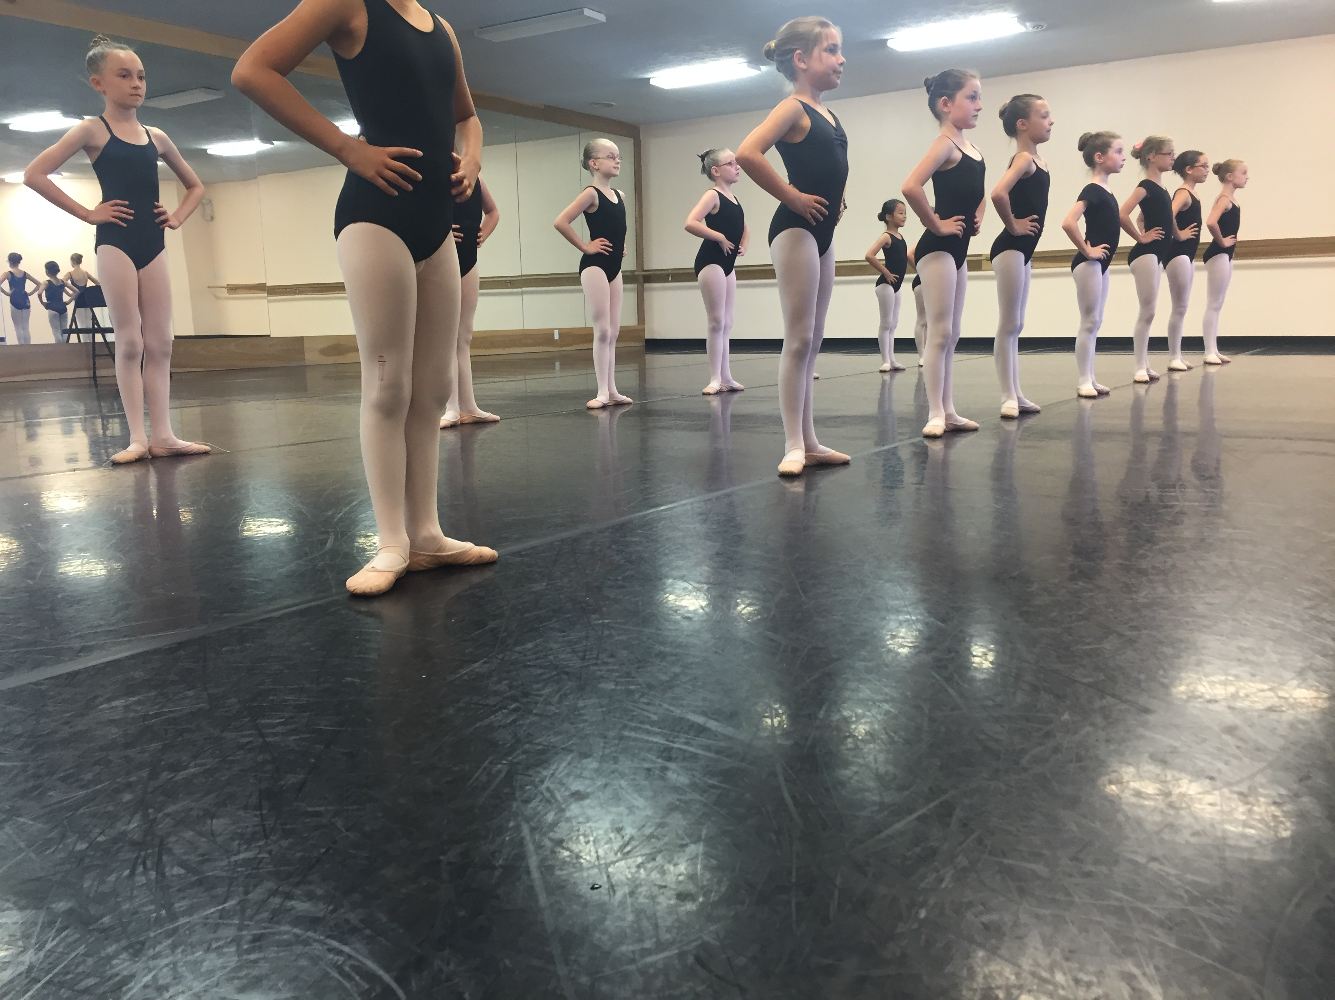
Please indicate on the application form your child’s current dance school, level and the number of years studied. Academy students up to level 3A. Please understand that each dance school would have a different title & standard for each level. YSBI’s faculty will divide students into levels according to age and ability as it relates to our intensive on the first day of classes.

CENTRAL INDIANA ACADEMY OF DANCE
14950 GREYHOUND COURT #4 CARMEL, IN 46032
317-581-2423 * studio@ciaodance.com

